**ANNUAL HONEY BEE CLASS**

Gateway Beekeepers Association

Basic Beekeeping Class

**FOR KING GEORGE AND SURROUNDING AREAS**

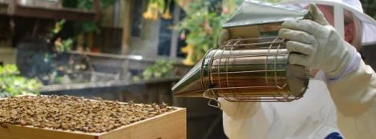**You’ll Learn:**

**- How to set up and manage hives**

**- Dynamics of the colony**

**- Sustainable beekeeping**

**- Honey harvesting**

**…. and SO Much more!**

**What’s Included?**

**16+ HOURS OF TRAINING**

**A MENTOR FROM THE CLUB**

**3 BOOKS ON BEEKEEPING**

**DIGITAL COPY OF COURSE FILES**

**1ST IN LINE TO BUY 2 NUCS OF BEES**

**1 YEAR CLUB MEMBERSHIP**

**(11 CLUB MEETINGS AND THE HONEY EXTRACTION PARTY)**

**TUESDAYS, Starting FEB. 7th, 2023**

**(8 Sessions)**

**6:30-8:45 PM**

**THE KING GEORGE CITIZENS CENTER**

**8076 Kings Highway, King George**

**COST IS $75 PER PERSON OR FAMILY**

**(1 set of Educational Mat**

**Contact:** [**www.gatewaybeekeepers.org**](http://www.gatewaybeekeepers.org)

[**Gatewaybeekeepers@gmail.com**](mailto:Gatewaybeekeepers@gmail.com)

**Facebook: Gateway Beekeepers Association**

**Club President: Mike Amorino (914) 804-4062**